Data Structure Algorithms & Applications
MIDTERM-SOLUTION
Question # 01) How data structure helps to solve real world problems. Give suitable examples. How to write an algorithm to solve particular problem and also discuss properties of a good algorithm.
Ans) 1. Role of Data Structures in Real-World Problems
Data structures help in organizing and storing data efficiently so that operations like searching, sorting, updating, and deleting can be performed quickly.
They make complex problems easy to manage and implement in real-life applications.
2. Real-World Examples
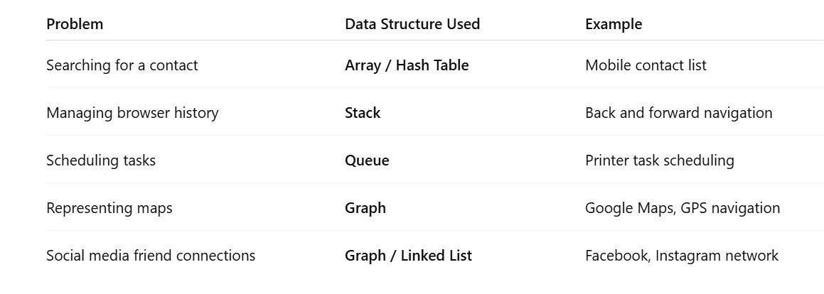
3. Writing an Algorithm (Steps)
Example Problem: Find the largest number in an array

Algorithm:
- Start
- Initialize max = arr[0]
- Repeat for each element i in array
If arr[i] > max, then max = arr[i]
- Print max
- Stop

4. Properties of a Good Algorithm
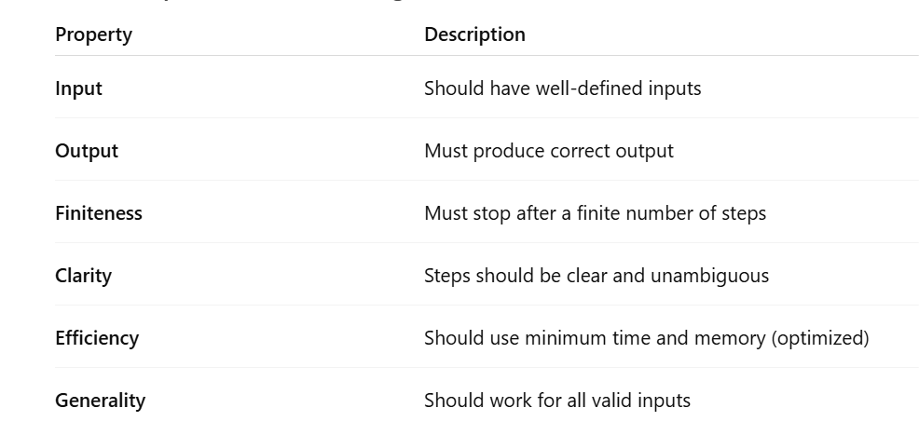

Question # 02) Part (a) and (b)
a) Given an array arr || of size N and a number K, where K is smaller than the size of the array. Write program to find the K'th smallest element in the given array. Given that all array elements are distinct.

Expected output:
Input: arr[](7, 10, 4. 3. 20, 15). K = 3
Output: 7
Input:
arr[17, 10, 4. 3, 20, 15), K-4
Output: 10
Ans) Program

import java.util.Arrays;
public class KthSmallestElement {
public static void main(String[] args) {
int[] arr = {7, 10, 4, 3, 20, 15};
int K = 3;
Arrays.sort(arr); // Step 1: Sort the array
System.out.println("Kth smallest element is: " + arr[K - 1]);
}
}
NOTE:
If K = 4 → Output will be 10.

b) b) With reference to Q2(a) what searching algorithm can be used and why? Analys its time complexity. Compare sequential and divide & conquer approach.
Ans) Which Searching Algorithm Can Be Used & Why?
We can use Binary Search after sorting the array because:
- Binary search works efficiently on sorted data.
- It follows the Divide and Conquer approach.
Binary Search (Divide & Conquer Approach)
- Divide the array into two halves.
- Compare the middle element with the key.
- Search in left or right half accordingly.
Time Complexity: O(log n)
(because the array size halves in every step)
Comparison: Sequential vs Divide & Conquer
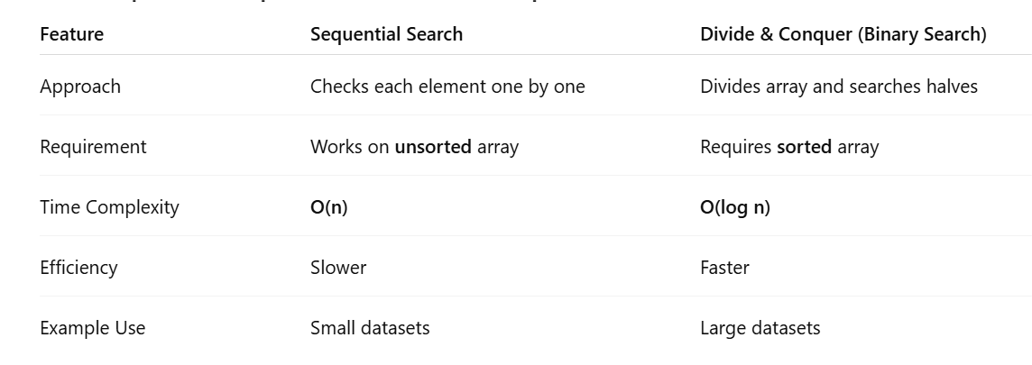

Question # 03) Discuss the challenges of unsorted data and how data structure cope with these challenges, list the various sorting algorithms and describe analysis criteria. For instance, if you are given an array consisting of the elements: [6, 3, 8, 2, 5, 7]. Discus the steps involved in bubble sorting and show the resultant array.
Ans) Challenges of Unsorted Data
Unsorted data makes searching, analysis, and management difficult. Major challenges include:
- Slow searching – Finding an element requires checking each item (O(n) time).
- Difficulty in comparison – Statistical operations (like finding min/max) take longer.
- Poor organization – Data cannot be efficiently processed or indexed.
- Duplication handling – Managing duplicates or relationships becomes harder.
- Increased processing time – Overall algorithm performance decreases.
How Data Structures Cope
Data structures like arrays, linked lists, trees, and heaps help by:
- Organizing data efficiently.
- Allowing sorting and searching using optimal algorithms.
- Enabling fast retrieval, insertion, and deletion.
Example: Using a Binary Search Tree (BST) or Heap, we can quickly sort or search elements in O(log n) time instead of O(n).

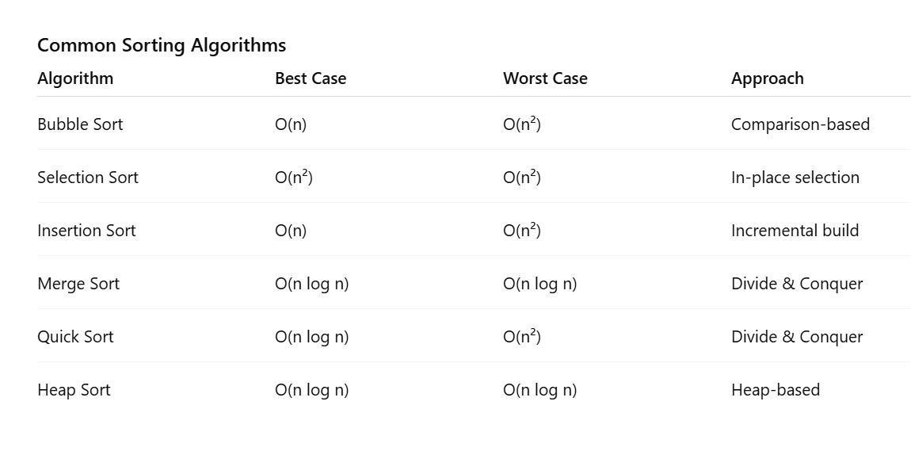
Analysis Criteria for Sorting Algorithms
- Time Complexity – How fast the algorithm runs.
- Space Complexity – How much extra memory it needs.
- Stability – Whether equal elements maintain their order.
- Adaptability – How well it handles partially sorted data.

Example: Bubble Sort Steps
Given array: [6, 3, 8, 2, 5, 7]
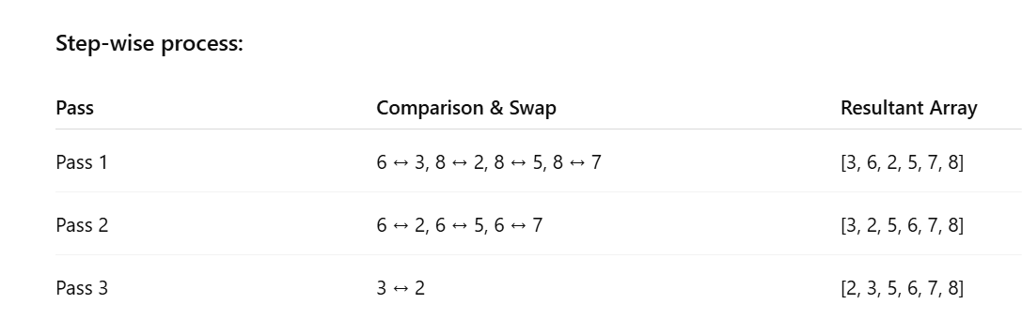
Final Sorted Array: [2, 3, 5, 6, 7, 8]

